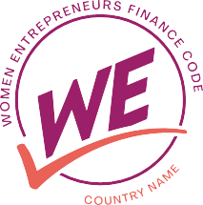

**National WE Finance Code Charter**

[Country name]

## DOCUMENT INFORMATION

|  |  |
| --- | --- |
|  | **Information** |
| Document Id | *(COUNTRY NAME)* Women Entrepreneurs Finance Code Charter |
| Document Owner | *(NAME)* |
| Issue Date |  |
| Author(s) | (*NAMES, TITLES)* |

DOCUMENT HISTORY

|  |  |  |
| --- | --- | --- |
| **Version** | **Issue Date** | **Changes** |
| 1.0 |  |  |
| 1.1 |  |  |
| 1.2 |  |  |
|  |  |  |
|  |  |  |
|  |  |  |

**Contents**

* 1. BACKGROUND 4
  2. CONTEXT 4
  3. GOALS 4
  4. GOVERNANCE 5
  5. NATIONAL COORDINATOR ROLE 5
  6. NATIONAL LEADERSHIP TEAM 5
  7. NATIONAL LEADERSHIP TEAM ROLES AND ACTIVITIES 6
  8. OPERATING PROCEDURES 7
  9. SIGNATORY RECRUITMENT 8
  10. ELIGIBLE SIGNATORIES & RECRUITMENT GOALS 8
  11. RECRUITMENT STRATEGY 8
  12. ONBOARDING PROCESS 9
  13. DATA COLLECTION & REPORTING MECHANISMS 10
  14. ROLE OF THE NATIONAL AGGREGATOR… 10
  15. DATA COLLECTION AND REPORTING PROCESS 10
  16. REPORTING ON ACTIONS TO SUPPORT WMSMES 11
  17. DEFINITIONS 12
  18. ANNEX 13
  19. CURRENT SIGNATORIES 13
  20. HIGH-LEVEL IMPLEMENTATION PLAN 14
  21. IMPLEMENTATION WORKSTREAM 15
  22. ADDITIONAL GUIDANCE ON CODE COMMITMENTS 16
  23. REPORTING PROCESS MAP 17



*What is the [Country] Code, what does this charter lay out and who contributed to it and approved it?*

1.0 Introduction

*What is the current state of financing and opportunity for WMSMEs in your country?*

*You may also include additional findings such as demand-side research on barriers WMSMEs face in accessing financing, financial sector perceptions about WMSME lending, etc.*

* 1. CONTEXT

*What do you hope to achieve by adopting the Code?*

Part A: *What are the* ***ultimate objectives you hope to achieve through the Code?*** For example, improving financing to women MSMEs*,* mainstreaming focus on the segment across a majority of financial services providers in key sectors, etc.

Part B*: What are the* ***practical metrics/targets*** *that will signal progress on those objectives?* For example getting X% of commercial banks to sign up to the Code by end of Year 2, closing the gender gap in MSME financing by X% by end of Year 3, etc.

* 1. GOALS

**Ultimate Objectives:**

**Metrics/Targets:**

# GOVERNANCE

*What is the role of the National Coordinator? What are their main responsibilities to facilitate Code implementation in your country?*

PART A: *What* ***high-level, long-term role*** *will the Coordinator play in promoting support for WMSMEs in your country?* For example: promoting the sharing of learnings on best practices to finance WMSMEs; identifying opportunities related to multilateral development bank financing, etc.

PART B: *What* ***specific responsibilities related to Code Implementation*** *will the Coordinator oversee during the first 1-3 years?* E.g. organizing Code committee meetings, tracking progress on key metrics and milestones, managing communications with the global We-Fi coordinators, etc.

2.1 ROLE OF THE NATIONAL COORDINATOR

*Which institutions are involved in making key decisions in this initial phase of Code implementation, and what role will they play in designing, launching, and scaling the Code?*

If available, you may also fill out the list Code Signatories as of Charter publication, found in the Annex (5.1).

2.2 INSTITUTIONS LEADING THE CODE

**Table 1: National Council/Executive Committee/Board/etc Members and Roles:**

|  |  |  |  |  |
| --- | --- | --- | --- | --- |
| **Name** | **Title** | **Institution** | **Institution Type** | **Role\*** |
|  |  |  |  |  |
|  |  |  |  |  |
|  |  |  |  |  |
|  |  |  |  |  |
|  |  |  |  |  |
|  |  |  |  |  |
|  |  |  |  |  |
|  |  |  |  |  |

* **Example roles**: data aggregator, NFS Working Group lead, recruitment strategist, etc

*What is the overall remit of the national leadership team? What are the main goals it plans to achieve over the next year years? It is recommended to fill out Table 2 with the key outputs and milestones for key activity.*

You may also develop a detailed Implementation Plan based on the models in Annex sections 5.2 and 5.3.

2.3 ROLE OF THE COUNCIL/EXECUTIVE COMMITTEE/BOARD/ETC AND MAIN ACTIVITIES

**Year one goals:**

**Year 2 goals:**

**Table 2: National Council/Executive Committee/Board/etc Key Outputs and Milestones**

|  |  |  |
| --- | --- | --- |
| **Goal** | **Key Outputs** | **Milestones** |
|  |  |  |
|  |  |  |
|  |  |  |
|  |  |  |
|  |  |  |

|  |  |  |
| --- | --- | --- |
|  |  |  |



Answer here: *How will the national leadership team meet, make decisions, and generate meaningful action?*

OPERATING PROCEDURES

2.4

# SIGNATORY RECRUITMENT AND ONBOARDING

*What types of FI signatories do you want to adopt the Code? What is the # of signatories to adopt the Code for Year 1 and Year 2, by FI type?*

3.1 ELIGIBLE SIGNATORIES AND RECRUITMENT GOALS

|  |  |  |
| --- | --- | --- |
| **Table 3: Recruitment Goals** | | |
| **FI Type** | **Year 1 Goal** | **Year 2 Goal** |
|  |  |  |
|  |  |  |
|  |  |  |
|  |  |  |

*What is the high-level strategy to persuade financial institutions to sign on? What incentives will be in place to persuade them?*

Incentives include the likes of access to financing guarantees and/or technical assistance from development finance ecosystem partners, awards from regulators or associations, etc.

* 1. RECRUITMENT STRATEGY AND INCENTIVES

*How will signatories officially commit to the Code and what will the onboarding process look like?*

If available, fill out Table 3 in the Annex (5.4) with more details on the three core commitments made by signatories: accountability mechanisms, reporting timeframes, and support they will receive in the form of technical assistance, peer learning programs, guidance documents, etc.

3.3 SIGNATORY ONBOARDING



4.0 DATA COLLECTION AND REPORTING PROCESS

*Which institution will act as the national aggregator for each signatory type? What is their role?*

For example, they may lead the Data Working Group for FSPs in their sector, draft or approve reporting templates, provide signatories with reporting guidance, follow up with signatories to collect data within the reporting timeframe, check and verify data, etc.

* 1. ROLE OF THE NATIONAL AGGREGATOR(S)

*Which aggregator will collect data from a given type of signatory? Who will the aggregator report data to, and in what format? What existing capabilities do they bring to this role, and/or what assistance or resources will they receive to support them?*

It may also be useful to visualize the reporting process – how data and information will flow from FSPs to the aggregator to the national Code leadership the global Code aggregators. An example reporting process map can be found in the Annex (5.5).

4.2 REPORTING PROCESSES: WMSME DATA

**Table 4: Data Aggregation Processes**

|  |  |  |  |  |
| --- | --- | --- | --- | --- |
| **Data Aggregator:** | **Collecting Data From:**  (e.g. commercial banks, Fintechs, MFIs, VC Funds, Angel syndicates, etc). | **Reporting Data to** (e.g. National Coordinator, OECD, etc.) | **Reporting Format** (e.g. cleaned anonymized data, aggregate data, analytical report with examples, etc.) | **Capabilities, Resources and Support**  (e.g. existing data collection mechanisms, support from development finance partner,  local consultancies, etc.) |
|  |  |  |  |  |
|  |  |  |  |  |
|  |  |  |  |  |

*What institution will collect information on incremental actions to support WMSMEs, and how will this be used at the national level?*

4.3 REPORTING PROCESSES: ACTIONS TO SUPPORT WMSMES

**Table 5: Information on**

|  |  |  |  |  |
| --- | --- | --- | --- | --- |
| **Institution Tracking Incremental Actions Taken to Support WMSMEs** | **Collecting Information From:** (e.g. commercial banks, Fintechs, MFIs, VC Funds, Angel syndicates, etc). | **Reporting To:**  (e.g. National Coordinator, WE Finance Code global  team, etc.) | **Reporting Format** (e.g. analytical report, list of examples, case studies, etc.) | **Capabilities, Resources and Support**  (e.g. annual survey of FSPs, support from development finance partner, local consultancies, etc.) |
|  |  |  |  |  |
|  |  |  |  |  |
|  |  |  |  |  |



*What national WMSME definition will be set for Code reporting? If not established yet, what is the process to decide it? Or if the definition will not be standardized, how will definitions be validated?*

* 1. DEFINITIONS

# ANNEX

*List all Code signatories as of the document date.*

5.1 NATIONAL CODE SIGNATORIES

|  |  |  |  |  |
| --- | --- | --- | --- | --- |
| **Institution Name** | **Institution Type (e.g. government body, commercial bank, association, development bank,**  **etc.)** | **Role in Code**  **(FSP Signatory, Ecosystem Partner, or Implementation Partner)** | **Name of Senior Leader Dedicated to Supporting WMSMEs** | **Additional Information/Notes** |
|  |  |  |  |  |
|  |  |  |  |  |
|  |  |  |  |  |
|  |  |  |  |  |
|  |  |  |  |  |
|  |  |  |  |  |
|  |  |  |  |  |
|  |  |  |  |  |
|  |  |  |  |  |
|  |  |  |  |  |
|  |  |  |  |  |

*Use or adapt this framework to create your own high-level plan for Code implementation in Year 1.*

* 1. HIGH-LEVEL IMPLEMENTATION PLAN

*HIGH-LEVEL IMPLEMENTATION PLAN:*

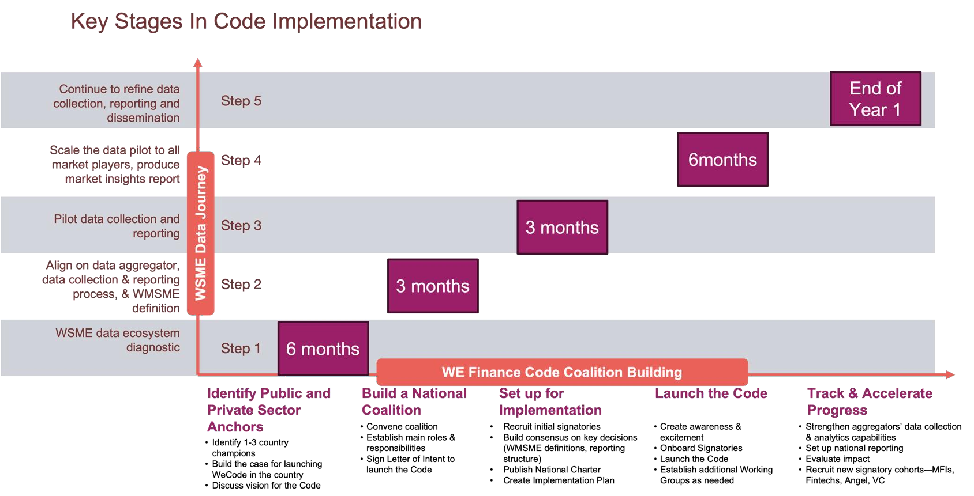

Figure 2: Key Stages in Code Implementation (Source: Financial Alliance for Women)

[**Download the WE Finance Code Action Plan**](https://financialallianceforwomen.org/vault/women-entrepreneurs-finance-code-action-plan/)

(Source: Financial Alliance for Women, developed for the WE Code Community of Champions)

[**Explore the WE Code Workshop**](https://docs.google.com/presentation/d/1yhkLnJ6ZSu9IYQXNjVJOXhdzqOb8YDhJ/edit#slide%3Did.p34) **in a Box**

(Source: https://[www.we-fi.org/we-finance-code)](http://www.we-fi.org/we-finance-code))

*Create a detailed workstream/action plan to track progress towards milestones in Year 1 of implementation (you may also adapt the attached Excel file).*

5.3 IMPLEMENTATION WORK PLAN

*EXAMPLE WORKPLAN:*

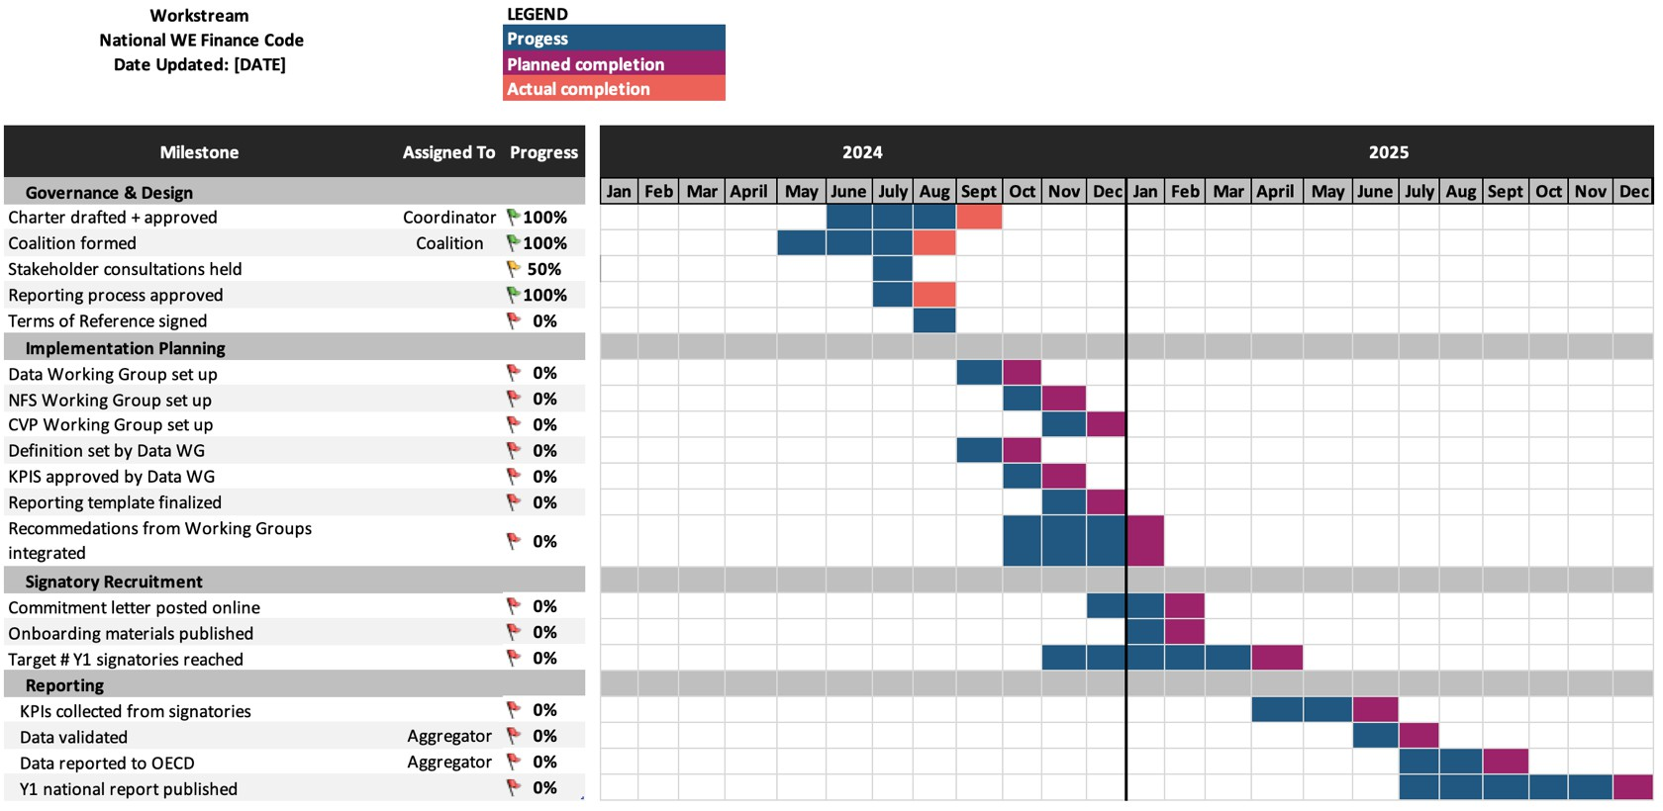

## Figure 3: Example workplan (Source: Financial Alliance for Women)

[**DOWNLOAD SAMPLE Code Implementation Workstream**](https://docs.google.com/spreadsheets/d/10yA2x8bp0xP4PQ-RPlfzld1Nome7OHFv6cI-Yyn0QcQ/edit?usp=sharing)

(Source: Financial Alliance for Women)

## ADDITIONAL GUIDANCE ON CODE COMMITMENTS

|  |  |  |  |
| --- | --- | --- | --- |
|  | **Commitment 1: Senior leader to drive support of**  **women-led businesses** | **Commitment 2: Actions to increase**  **WMSME lending** | **Commitment 3: Sex-disaggregated**  **data to be reported** |
| Commitment details | *Specify management level here:* | *Specify potential actions here:* | *Specify core indicators here:* |
| Accountability mechanisms | *Share how follow-through on commitment will be tracked at the national level:* | *Share how follow-through on commitment will be tracked at the national level:* | *Share how follow- through on commitment will be tracked at the national level:* |
| Expected timeline | *Detail when the signatories are expected to name the senior leader driving support for women-led businesses (e.g. in their commitment letter, or within one month of signing, etc.):* | *Detail when the signatories are expected to report on actions taken (e.g. within one year):* | *Detail when the signatories are expected to report on required indicators (e.g. within two years):* |
| Support provided | *Share what support will be provided to follow through on commitment (e.g. trainings or launch event for Senior Leaders)* | *Share what support will be provided to follow through on commitment (e.g. menu of actions with guidance and best practice examples):* | *Share what support will be provided to follow through on commitment (e.g. technical assistance for X# of FIs with low capacity to report):* |

* 1. EXAMPLE REPORTING PROCESS MAP

OECD

Reports national data to the global aggregator (OECD)

WE-Fi

Reports on key actions, milestones, and impact to WE-Fi

Report cleaned, anonymized data to the National

National Coordinator

Report on key indicators to respective Aggregators

National

Aggregator (Commercial Banks)

Commercial Banks

National Aggregator (MFIs)

Microfinance Institutions

National Aggregator (Fintechs)

Fintechs

Report on key actions to National Coordinator